TITLE
Living with ‘melanoma’…for a day: a phenomenological analysis of medical students’ simulated experiences

RUNNING HEADER
Simulating melanoma patients’ life experiences

NAMES OF AUTHORS
M Corr^{1*}, G Roulston^{2*}, N King³, T Dornan², C Blease⁴, GJ Gormley²
- Foundation Programme, Northern Ireland Deanery
- Centre for Medical Education, Queen’s University Belfast, Northern Ireland
- School of Human and Health Sciences, University of Huddersfield, England
- School of Philosophy, University College Dublin, Ireland and Program in Placebo Studies, Beth Israel Deaconess Medical Center/Harvard Medical School, Boston.
* Joint first author

CORRESPONDING AUTHOR
Dr Gerard J Gormley
Department of General Practice (QUB)
Dunluce Health Centre (4th Floor)
1 Dunluce Avenue, Belfast BT9 7HR
g.gormley@qub.ac.uk

FUNDING SOURCE
Small research grant from the Irish Network of Medical Educators (INMED)

CONFLICTS OF INTEREST
The authors declare no conflict of interests

BULLET STATEMENTS

What’s already known about this topic?
Despite the rising incidence of melanoma, medical students have progressively fewer opportunities to encounter patients with this form of cancer. Beyond diagnosing and managing such patients, it is important to consider the impact that such a condition can have on their lives. Experiential learning opportunities can provide a powerful experience, but are limited when relating to cancer.

What does this study add?
Temporary melanoma transfer tattoos, in combination with a patient’s account of receiving their diagnosis, can afford medical students a modest but potentially important immersive introduction to some of the lived experiences of having melanoma.

What are the clinical implications of this work?
Such an inexpensive simulation modality shows promise in prompting medical students to reflect critically on how they could treat patients with melanoma more empathetically in the future.

RESEARCH ETHICS
This study received ethical approval by the Research Ethics Committee (School of Medical, Dentistry and Biomedical Sciences, QUB) (Ref 14/37v2). Written informed consent was obtained from all subjects in this study.

ABSTRACT

Background
Despite the rising incidence of melanoma, medical students have progressively fewer opportunities to encounter patients with this important condition. Curricula tend to attach the greatest value to intellectual forms of learning. Compared to intellectual learning, however, experiential learning affords students deep insights about a condition. Doctors who experience ill health are more empathic towards patients. However opportunities to learn about cancer experientially are limited. Temporary transfer tattoos can simulate the ill health associated with melanoma. We reasoned that, if doctors who have been sick are more empathic, temporarily ‘having’ melanoma might have a similar effect.

Objectives

Explore the impact of wearing a melanoma tattoo on medical students’ understanding of patienthood and attitudes towards patients with melanoma.

Methods
Ten fourth year medical students were recruited to a simulation. They wore a melanoma tattoo for 24 hours and listened to a patient’s account of receiving their diagnosis. Data were captured using audio-diaries and face-to-face interviews, transcribed, and analysed phenomenologically using the template analysis method.

Results
There were four themes: 1) Melanoma simulation: opening up new experiences;
2) Drawing upon past experiences; 3) A transformative introduction to patienthood;
4) Doctors in the making: seeing cancer patients in a new light.

Conclusions

By means of a novel simulation, medical students were introduced to lived experiences of having a melanoma. Such an inexpensive simulation can prompt students to reflect critically on the empathetic care of such patients in the future.

INTRODUCTION

The empathy challenge
Compassion should be intrinsic to healthcare, but it is ever harder to promote this under the pressures of today’s clinical education and practice [1-4]. Formal curricula and training may lead to a further disconnect between biomedical knowledge and empathic care. A wealth of evidence suggests that medical students’ levels of empathy declines during medical school and residency [5-8], although this may not be true of all medical schools and students [9]. The apparent decline in empathic care has implications for (among other things) healthcare outcomes, patient satisfaction, and medico-legal risk [5-7]. Experiential learning is one forum, which may help to mitigate declines in empathy, by fostering deeper understanding of patient perspectives, and transforming how learners behave [10-12]. We already know, for example, that ill doctors’ experiences of patienthood can make them more empathic by reconciling their intellectual and emotional responses [13-16]. Medical education is therefore challenged to find ways to improve empathic care.

Simulating ‘patienthood’
Simulating illness gives healthy learners vicarious experiences of patienthood [17, 18]. Wearing body suits, for example, simulates physical debility [19]. Cancer generates enormous fear and concern [20] but is hard to simulate because its symptoms can be non-specific. Malignant melanoma is an exception. It can be a life-limiting if not diagnosed early [21-23]. Lectures and online learning materials teach facts about it, but students may never encounter melanoma during all-too-short clinical attachments [24-25]. Practical and ethical barriers prevent real patients with newly diagnosed melanoma participating in clinical teaching with large cohorts of medical students.

Temporary transfer tattoos [26] can be applied to simulated patients to test students’ ability to recognise melanoma and empathically communicate the diagnosis [27]. The educational benefits of wearing tattoos have not, however, been explored. We reasoned that, if doctors who have been sick are more empathic, temporarily ‘having’ melanoma might have a similar effect [28].

OBJECTIVE
We set out to explore the impact of wearing a melanoma tattoo on medical students’ understanding of patienthood and attitudes towards patients with this form of cancer.

METHODS
Ethical approval was given by the School of Medicine’s Research Ethic Committee, Queen’s University Belfast (QUB) (Ref 14/37v2).

Conceptual orientation
Interpretive phenomenology is a well-established approach to the analysis of first-person experience, which can produce valid knowledge [29]. Through qualitative analysis of first-person accounts, phenomenology examines people’s reported experiences in order to understand a phenomenon as it exists in their consciousness. This provided an appropriate conceptual framework for examining and interpreting the richness of student experiences. More specifically, the validity of our interpretation rests on Merleau-Ponty’s theory of embodied experience [30]. This focuses not just on objective bodily (i.e. physiological) experiences, but also on perceptual, intentional and embodied dimensions of experiences, embedded in their sociocultural contexts. .

Setting, Recruitment and Sampling
Students’ dermatology education is in the third year of QUB’s five-year medical undergraduate programme and consists of a mixture of online learning, lectures, and clinic attendance. As is typical of phenomenological research, our sample size was deliberately small (10 students) so that the depth of the analysis was not compromised by sheer volume of text [29].

We emailed fourth-year medical students (n=83) who were taking part in a General Practice module (in academic year 2014-2015) inviting them to take part, and entered the demographic characteristics of willing participants into a sampling matrix (Table 1). We purposefully recruited a sample that represented the age, gender, and maturity of the whole of the year group. Participants gave informed, written consent. We selected fourth year students to ensure that all had received dermatology teaching in the previous year.

Pseudonym | Age  (years) | Sex  (M/F) | Graduate Entry Status (Y/N)
George | 21 | M | N
Thomas | 23 | M | N
Amy | 21 | F | N
Sarah | 25 | F | Y
Jane | 22 | F | N
Victoria | 22 | F | N
Kevin | 24 | M | Y
Katy | 21 | F | N
Mark | 22 | M | N
Claire | 22 | F | N
Table 1. Participant demographic details and pseudonyms

The immersive simulation
A patient gave permission for an image of their newly diagnosed melanoma to be turned into a transfer tattoo (Fig 1-2) and audio-recorded an account about receiving the diagnosis.

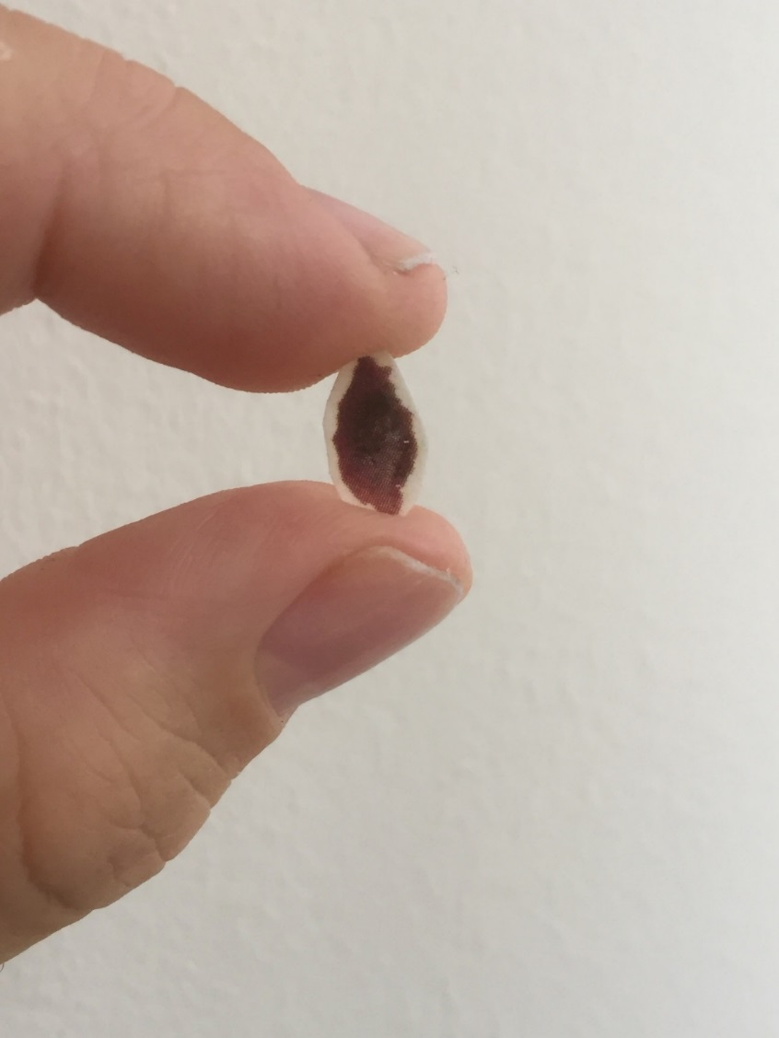

Figure 1. Image of patient’s malignant melanoma made into a temporary transfer tattoo

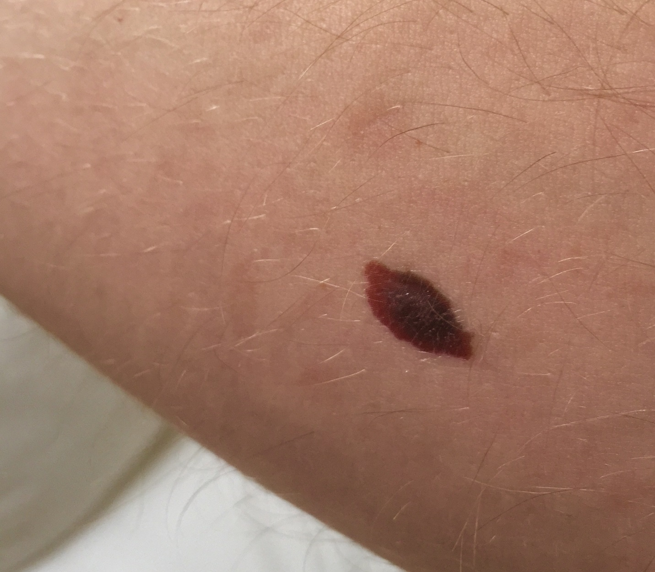

Figure 2. Image of a melanoma transfer tattoo applied to a participant’s arm.

During 30-minute briefings, one of us applied a tattoo to participants’ forearms (Figure 2), played the recorded narrative, and instructed them to go about their normal lives for the next 24 hours.
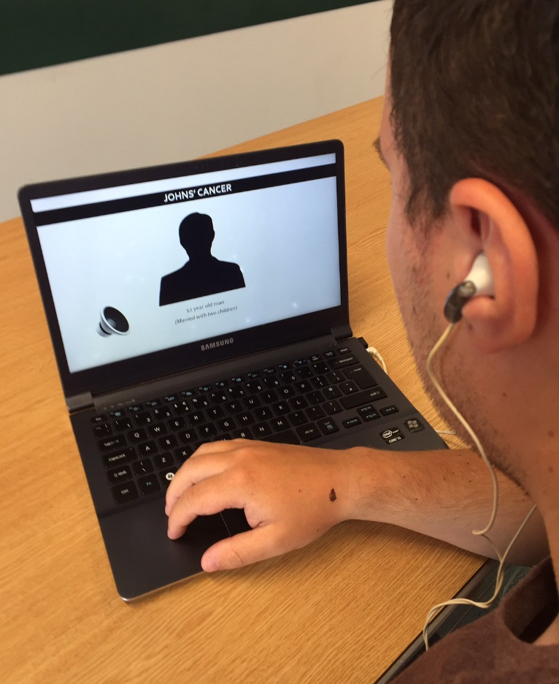
*Figure 3. Illustration of a medical student wearing a melanoma tattoo - whilst listening to a patient’s narrative of their experience receiving a diagnosis of a melanoma
*(Patient’s name on display a Pseudonym)

We asked them to reflect critically on the experience of receiving a diagnosis of malignant melanoma. After 24 hours they were asked to remove the temporary tattoo using soapy water.

Data Capture
Participants were asked to audio-record reflections on their experiences four times at regular intervals over the 24 hours they wore the tattoo, and then give one-to-one, exploratory, open-ended audio-recorded interviews immediately afterwards. They were also asked to reflect back on their experience in an audio-recording 3 months later. Ten participants took part in the study generating 173 minutes of audio-diary and 193 minutes of interview data. Recordings were transcribed verbatim and participant’s assigned pseudonyms (see Table 1). Citations, below, give pseudonyms and are coded: Int=Interview; AD=audio-diary.

Analysis
Our approach was within the broad interpretive phenomenological tradition [31], using Template Analysis [32] as our analytical procedure. Template Analysis is a generic form of thematic analysis which may be used from a variety of methodological positions [33], including phenomenology [34-36]. It involves the construction of an initial coding template, usually on the basis of a subset of the data; this is then applied to further data, modified as necessary, and reapplied until all data are coded to a final version of the template. In accordance with a phenomenological orientation, we ensured our analysis focused on immediate experience, rather than drawing on prior theory. Four of the researchers worked together to develop an initial template based on four transcripts. A colleague who was not part of the research team also contributed to this stage, providing an external critical perspective on the developing template. The template was then developed iteratively through application to further transcripts, with a mixture of face-to-face and remote input from different members of the team. This regular communication between researchers heightened their reflexivity and guarded against undue influence of any one person’s perspective. We sent the interpretation to participants and invited comments as a further validation step.

RESULTS
Analysis yielded four main themes: 1) Melanoma simulation: opening up new experiences; 2) Drawing upon past experiences; 3) A transformative introduction to patienthood;
4) Doctors in the making: seeing cancer patients in a new light.

Melanoma simulation: opening up new experiences

Experience of the simulation technologies and techniques
The simulation gave an immersive, distinctive and personal experience. This engaged participants, in their imaginations, in the experience of having a melanoma.

“…I found myself worrying … about it, even though I know that it’s not actually real…. there is something about when you look at it, just because of the nature of it, it does stand out and at times it did feel real….” [Mark, AD]

Participants toggled between seeing the simulation as a novelty role-play, and having a sense of suspended disbelief. Unsurprisingly, the visual presence of the tattoo dominated their experience and this impact lasted throughout the 24 hours. As the melanoma tattoo remained in situ for 24 hours, there was a persistency to the visual stimulus and cues provided by the image. When the simulation role-play was not in the forefront of participants’ minds, catching sight of the melanoma tattoo provided a strong cue and drew their attention to the simulation.

“If I hadn’t been able to see it I’d have forgotten about it. If it had been on the back of my…. I don’t think it would have played on my mind as much…... But definitely, obviously driving the car you could see it, doing the dishes you could see it” [Sarah, Int]

The tattoo being a direct copy of a real patient’s melanoma was an important mediator of participants’ experiences, which was reinforced by the audio narrative

“….the fact that it was …. a melanoma that someone actually had, I think had much more of an impact than if it had just sort of been graphically designed.”
[Mark, Int]

In addition to the visual experience, the audio narrative provided by the actual patient provided an important dimension to the simulation.

“The narrative made it very real, that it’s not just a sticker but there’s actually a person and it affected this person. I think hearing the narrative definitely helped as well.” [Sarah, Int]

The tattoo stimulated participants physically as well as visually, triggering a deep, visceral experience.

“… I just felt something weird to do with my left arm. It was very fleeting moments, … you could almost just feel… I don’t even know how to describe it but you were just aware of something physical, that even if your jumper was on it you just knew that if you pulled the jumper up that it would be there.” [Mark, Int]

‘A dirty mark’
The tattoo provoked a strong sense of being ‘marked’, which made participants’ self-conscious. They wanted to hide it from themselves and others.

“People would have looked at it, 'what is that?' Is it dirty?' I think a lot of people would see it and (think) 'what is wrong with them?’ …. So … I wasn't showing it off freely.” [Claire, Int]

Reaction by others: extending the simulation experience
The simulation extended participants’ learning beyond the classroom into their daily social interactions. Other individuals’ reactions, in those wider settings, was often emotive.

“I was speaking with my housemate…….and I showed him the mole and he immediately said “that looks worrying, you should see your doctor”. You know he did seem genuinely worried, which is good to know that he actually, genuinely worried about me!” [Kevin, AD]

Drawing upon past experiences
The simulation triggered participants to draw upon earlier life experiences unrelated to their status as trainee health professionals; either personal to themselves:

“As I said it made me remember about a mole I had on my back that I had which I haven’t seen since I got it checked out two or three years ago….. So the fact that, if I imagined this to be a real melanoma, it would cause me to present a lot sooner.” [Mark, AD]

Or to others they knew:

“It brought back memories of cancer experiences in my family…my grandmother had cancer…and I would have taken her to the [Cancer] suite to get her chemotherapy… so we got to know everybody in the place, and I would have been talking to young guys, 25, 35, who had skin cancer and were receiving chemotherapy. So it brought back all those memories” [Thomas, Int]

As senior medical students, it was natural for participants to explore earlier educational experiences.

“I suppose as medical students we’re aware of things like that, and maybe would be more sensitive and would do things like check our moles and maybe be more aware of that, whereas for the general public it’s not so much to their attention, and they maybe wouldn’t think about it.” [Amy, AD]

Participants also drew on humanistic aspects of patients they had encountered as well as clinical aspects of melanoma.

“… I guess maybe over the last number of years we’ve become slightly numb to seeing certain things, in terms of we’ve seen lots of pictures in text books and things like that.” [Mark, Int]

A transformative introduction to patienthood

‘Walking around in patients’ shoes’
Participants reflected on the emotions of a melanoma being diagnosed. They experienced aspects of fear and some anxiety.

“I know that it’s a temporary tattoo, but I’m really conscious that it’s there on my arm. So I see why patients would worry, and….having to wait for a diagnosis could be horrible for them. But they just have to wait….and not really knowing what’s going on.” [Sarah, AD]

The disruption to patients’ lives came into perspective. Participants empathised with them and their families and friends.

“I think it … just … kind of hit home again…..the worry involved … it’s not just that it affects you, it affects your family as well.” [George, Int]

The emotional impact of exploring patients’ imagined lifeworlds (i.e. all of the immediate experiences, activities, and interactions that make up an individual’s life) was tempered by the relief that this was a temporary state. ‘Real’ melanoma patients cannot ‘wash their cancer away’.

“I washed the melanoma tattoo off in the shower this morning and there was definitely a good sigh of relief ….I didn’t have to look at it anymore…. Real patients don’t get that option” [Mark, AD]

Participants felt vicariously guilty for bad habits that had caused their imagined melanoma.

“I suppose you would automatically … start blaming yourself. Thinking why did I not notice this mole earlier? Is this because I spent too much time in the sun? You know sort of blaming yourself…. and thinking that you should have prevented this ... feeling angry at yourself, feeling guilty is only going to make the whole process even more traumatic and distressing.” [Amy, AD]

Participants also felt guilty about the impact on others close to them. Closely aligned to this awareness was a sense of loss.

“… when you see families, see people dropping their kids off to schools and you’ll think to yourself, I’m not going to have that. I have a cancer, my whole world is falling to pieces, all my plans, all my ideas, all my hopes in this world is just going to stop for the meantime….I don’t think that would be a nice thing.” [Kevin, AD]

These negative emotions made them appreciate aspects of their lives, particularly relationships.

“….and you appreciate things a lot more, I think, and life is short as it is but when it’s as short as that you prioritise the important things. Your mobile phone isn’t the most important thing in life …, it’s your friends, it’s your family, it’s spending time with people...” [Thomas, Int]

Doctors in the making: seeing cancer patients in a new light
Being medical students was integral to participants’ experiences. They reflected critically on their professional development and the ways they hoped to interact with patients in the future.

“So it’s definitely been a valuable experience and I will no doubt reflect on it and hope to implement on it in my own practice and just remember what it felt like to have something that, even though it wasn’t, even though I knew it was harmless, it still caused worry.” [Mark, AD]

Participants’ reflections on their experiences opened up their imaginative sensibility to the patient ‘behind’ the melanoma and the social dimension of the diagnosis. They recognised that doctors need to be mindful of this.

“As they always say, you're treating a patient, not the condition. So that's what it sort of made me feel like. You don't think about the patient. Well, you should think about the patient even after they leave the room, what their life is. You don't think about their daily interactions or what people will say to them ... I think it does maybe make you think a bit differently.” [Katy, Int]

Experiencing the simulation prompted participants to consider how they could best interact empathically with future patients.

“Maybe just give them more time to express... You need to have someone to listen to you, more time to express how they feel about actually having a melanoma…. I feel like patients might keep things inside and not discuss it. So maybe give them the opportunity to talk about it.” [Katy, Int]

Participants’ enhanced appreciation of patients as people persisted three months after the simulation. They continued to reflect on how best to empathise with patients.

“So I began integrating this experience into some of the sessions that I have with the patients on the wards, asking them open questions and truly, truly wanting to know what they are doing with their experience, with that genuineness that I really…. want to know about their experience, and surprisingly they open up to me and I found that I got more than what I initially intended to learn from them.” [Jane, AD]

DISCUSSION
This study shows how simulation can help medical students experience, and empathise with experiences of patients diagnosed with melanoma. It did not recreate the experience; however, it broadened and deepened their perspectives and understanding. Reflecting critically about what it would be like to have melanoma fostered patient-centred attitudes towards the experience of having this important form of cancer.

Simulating a melanoma diagnosis: Fake, ‘genuine fake’, or real?
Transfer tattoos, coupled with a patient’s account of having a melanoma, provided an immersive learning experience. It mattered not only that the melanoma tattoo was prominently located but also that the image used was of a real melanoma. The synergy between visual and audio dimensions of the simulation helped students make a deep connection with a patient with melanoma. Crucial to this experience was the persistency to the simulation throughout 24 hours. During this time, students merged their simulation experience into their daily routines. Simulation technology, especially the use of plastic manikins, can dehumanize learning experiences [37-39]. In this simulation, however, learners’ self-acting as a patient with a melanoma brought a very human, personal dimension. Reactions by others provided an important extra layer of realism.

Opening a door to patienthood
Participants toggled between being a doctor-in-training and a ‘melanoma’ patient. This elicited powerful emotions and experiences, especially among such young individuals. They learned sociological and psychological perspectives on patienthood that went beyond the biomedical dimension of having a melanoma. Participants grounded these experiences by looked inwardly to themselves and what it might be like to have a melanoma diagnosis. They learned the meaning and emotional impact of illness on people’s lives, including how it constrains their actions.

As with actual cancer patients, a sense of loss, guilt and stigma were prominent experiences [20, 40]. In the safe space of a learning experience, students began to explore a less protected view of life and mortality. As with illness, this simulation appeared to disrupt (albeit in a careful and restricted way) the naïve belief that well-being is a given. Through this experience, a number of students reflected – if only briefly – on what they took for granted in their own lives – a realisation often experienced by cancer patients [40, 41]. The stigma that can be associated with illness, particularly the visible disfigurement of a skin lesion, was also experienced. This was especially evident in, and in the anticipation of, social interactions. The visibility of the melanoma provided the opportunity for students to experience the obtrusiveness of the physical representation of a genuine malignant melanoma. Such an experience prompted students to reflect critically on their personal experience and the undesired attitude that others had, or might have, towards them as someone with a visible melanoma.

Impact on attitudes as future doctors
Medical education aims to instil in students both personal and professional self-awareness; where they are capable of reflectively evaluating themselves so that they pursue and self-direct their further development. Simulation has the potential to allow learners to explore the boundaries of their clinical competence in order that they might draw upon these experiences in the interest of their professional development. As such, simulation pedagogy can afford students an opportunity to ‘know thyself’ and critically reflect on this in their identity formation as future doctors.

Through this simulation experience, students got to consider some of the ways that they, as future doctors, could demonstrate compassion to patients. More often what resonated with students was that often ‘the small things’ really counted. What might appear as trivial may actually be of considerable importance to patients – for example, doctors spending more time with patients and exploring their feelings and worries.

Strengths and limitations of study
This study had a number of strengths. Firstly, the number of patients being diagnosed and living with melanoma is steadily increasing and there is an imperative to advance pedagogical methods of how best we train healthcare professionals in caring for these patients [21]. Secondly, the simulation techniques used in this study are novel, reproducible and relatively inexpensive (material cost of c.£0.01 per tattoo) [26]. Lastly, we deployed a mixed approach to data capture in this study; either method could compensate for any deficiencies of the other method.

However the strengths of the study have to be considered alongside its limitations. Given the theoretical orientation in this study, generalisability was never an objective. Moreover, this study was exploratory in nature, illuminating the fine-grained nuances of medical students’ lived experience of simulating a melanoma diagnosis. Finally, whether the attitudinal changes generated by the simulation produce long-term changes, especially in clinical practice, remains to be seen, and was beyond the remit of this study.

Implications for practice and future research
This relatively inexpensive form of simulation is reproducible and readily complementary to traditional forms of dermatology teaching both for medical students and potentially other healthcare professionals such as GP trainees. It would be of interest to consider patients’ experiences of medical students who have engaged in such a dermatology simulation-based learning activity.

CONCLUSIONS
The findings of this study indicate that by means of a novel simulation-based learning activity, it is possible to afford medical students a modest but potentially important introduction to some of the lived experiences of a patient who has a melanoma. Beyond the biological account from traditional teaching, the experience provides insights to patients’ lifeworlds. Overall, this simulation modality could complement traditional dermatology teaching methods, providing a greater appreciation of the patient, and their lifeworlds, behind the melanoma skin lesion.

ACKNOWLEDGEMENTS
We are particularly grateful to the patient who kindly offered the image of his melanoma and an audio account of him receiving his diagnosis. The authors would like to thank Dr Finbar McGrady who provided dermatology advice with this project and Professor Karen Mann for constructive feedback on this research manuscript. Finally we would like to thank the medical students who participated in this research.

REFERENCES
- Francis R. (2013) Report of the Mid Staffordshire NHS Foundation Trust Public Inquiry. The Stationary Office, England.
- de Zuleeta P. Suffering, compassion and 'doing good medical ethics'. J Med Ethics 2015;41:87-90
- Smajdor A, Stöckl A and Salter C. The limits of empathy: problems in medical education and practice. J Med Ethics 2011;37:380-383
- Blease C. In defence of utility: the medical humanities and medical education. Medical Humanities. 2016; 1;42(2):103-108
- Moore PJ, Adler NE, Robertson PA. Medical malpractice: the effect of doctor-patient relations on medical patient perceptions and malpractice intentions. Western Journal of Medicine. 2000;173(4):244
- Hojat M, Mangione S, Nasca TJ, Rattner S, Erdmann JB, Gonnella JS, Magee M. An empirical study of decline in empathy in medical school. Medical Education. 2004;38(9):934-941
- Neumann M, Edelhäuser F, Tauschel D, Fischer MR, Wirtz M, Woopen C, Haramati A, Scheffer C. Empathy decline and its reasons: a systematic review of studies with medical students and residents. Acad Med. 2011;86(8):996-1009
- Hojat, M., Vergare, M.J., Maxwell, K., Brainard, G., Herrine, S.K., Isenberg, G.A., Veloski, J. and Gonnella, J.S. The devil is in the third year: a longitudinal study of erosion of empathy in medical school. Academic Medicine. 2009;84(9):1182-1191.
- Quince TA, Parker RA, Wood DF, Benson JA. Stability of empathy among undergraduate medical students: a longitudinal study at one UK medical school. BMC medical education. 2011;11(1):1.
- Afghani B, Besimanto S, Amin A, Shapiro J. Medical students' perspectives on clinical empathy training. Educ Health 2011;24(1):544
- Cook DA, Hatala R, Brydges R, Zendejas B, Szostek JH, Wang AT, Erwin PJ, Hamstra SJ. Technology-enhanced simulation for health professions education: a systematic review and meta-analysis. JAMA 2011;306(9):978-988
- Issenberg SB, McGaghie WC, Petrusa ER, Lee Gordon D, Scalese RJ. Features and uses of high-fidelity medical simulations that lead to effective learning: a BEME systematic review. Medical Teacher 2005;27:10–28
- Klitzman R. Improving Education on Doctor–Patient Relationships and Communication: Lessons from Doctors Who Become Patients. Academic Medicine 2006;81:447-453
- Heymann J. Equal Partners: A Physician’s Call for a New Spirit of Medicine. Boston: Little Brown, 1995.
- Mandell H, Spiro H, (eds). When Doctors Get Sick. New York: Plenum, 1987.
- Fromme EK, Hebert RS, Carrese JA. Self-doctoring: a qualitative study of physicians with cancer. J Fam Pract 2004;53:299–306
- Welborn TA, Duncan N. Diabetic staff simulation of insulin-dependent diabetic life. Diabetes Care 1980;3(6):679-681
- Dearing KS, Steadman S. Challenging stereotyping and bias: a voice simulation study. J Nurs Educ 2008;47(2):59-65.
- Eymard AS, Crawford BD, Keller TM. “Take a Walk in My Shoes:” Nursing students take a walk in older adults’ shoes to increase knowledge and empathy. Geriatr Nurs. 2010;31(2):137–141
- Simard S, Thewes B, Humphris G, Dixon M, Hayden C, Mireskandari S, Ozakinci G. Fear of cancer recurrence in adult cancer survivors: a systematic review of quantitative studies J Cancer Surviv 2013;7:300–322
- Cancer Research UK. Skin cancer incidence statistics. London: Cancer Research UK. Available online from: http://www.cancerresearchuk.org/cancer-info/cancerstats/types/skin/incidence/ Last accessed October 2016
- de Vries E, Coebergh JW. Cutaneous malignant melanoma in Europe. Eur J Cancer 2004;40(16):2355–2366
- Dennis LK. Analysis of the melanoma epidemic, both apparent and real: data from the 1973 through 1994 surveillance, epidemiology, and end results program registry. Arch Dermatol 1999;135(3):275–280
- Chiang YZ, Tan KT, Chiang YN, Burge SM, Griffiths CE, Verbov JL. Evaluation of educational methods in dermatology and confidence levels: a national survey of UK medical students. Int J Dermatol 2011;50:198–202
- Burge S. Teaching dermatology to medical students: a survey of current practice in the UK. Br J Dermatol 2002;146:295–303
- Gormley GJ, Menary A, Layard B, Hart N, McCourt C. Temorary Tattoos: a novel OSCE assessment tool. The Clinical Teacher 2013;10(4):251-257
- Langley RGB, Tyler SA, Ornstein AE, Sutherland AE, Mosher LM. Temporary tattoos to simulate skin disease: report and validation of a novel teaching tool. Acad Med 2009;84:950–953
- Klitzman R. When doctors become patients. Oxford University Press; 2007
- Lopez KA, Willis, DG. Descriptive Versus Interpretive Phenomenology: Their Contributions to Nursing Knowledge. Qualitative Health Research 2004;14(5):726-735
- Merleau-Ponty, M. Phenomenology of Perception. London: Routledge & Kegan Paul, 1962.
- Langdridge, D. (2004) Phenomenological Psychology: Theory, Research and Method. Harlow: Pearson Education.
- King, N. Doing template analysis. In G.Symon and C.Cassell (eds) Qualitative Organizational Research: Core Methods and Current Challenges. London: Sage, 2012.
- Brooks, J., McCluskey, S., Turley, E. and King, N. (2015) The utility of template analysis in qualitative psychology research, Qualitative Research in Psychology, 12 (2), pp.202-222.
- Hardy B, King N, Rodriguez A. The experiences of patients and carers in the daily management of care at the end of life. International Journal of Palliative Nursing 2014;20(12):591-598.
- King, N, Carroll, C, Newton, P & Dornan, T (2002) ‘You can’t cure it so you have to endure it’: The experience of adaptation to diabetic renal disease. Qualitative Health Research. 12 (3), 329-346.
- Turley, E. (2016) ‘Like nothing I’ve ever experienced before’: understanding consensual BDSM as embodied experience. Psychology and Sexuality, 7 (2), 149-162.
- Issenberg SB, McGaghie WC, Hart IR, Mayer JW, Felner JM, Petrusa ER, Waugh RA, Brown DD, Safford RR, Gessner IH, Gordon DL, Ewy GA. Simulation Technology for Health Care Professional Skills Training and Assessment. JAMA. 1999;282(9):861-866
- Milton CL. Ethical Issues Surrounding Interprofessional Collaboration. Nursing Science Quarterly 2013;26(4)316–318
- Walsh M. Narrative pedagogy and simulation: Future directions for nursing education. Nurse Education in Practice 2011;11(3):216-219
- Carel HH. Illness, phenomenology, and philosophical method. Theoretical medicine and bioethics. 2013;34(4):345-357
- Carel HH. Illness: The cry of the flesh. Stocksfield, UK: Acumen, 2008.

